All data

Linear regression

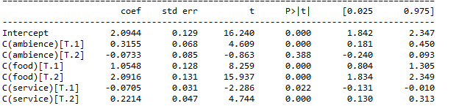

Logistic regression

Star = 1

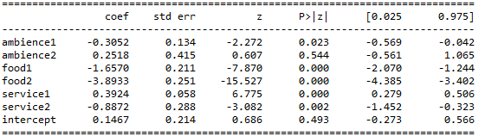

Star = 2

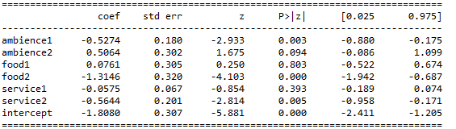

Star = 3

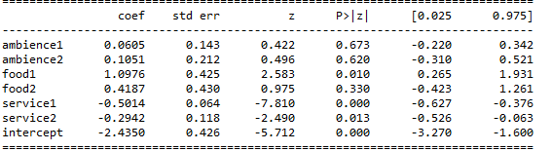

Star = 4

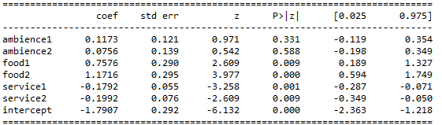

Star = 5

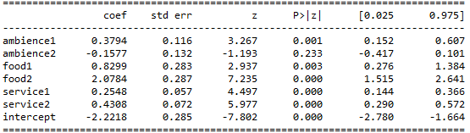

Chinese food

Linear regression

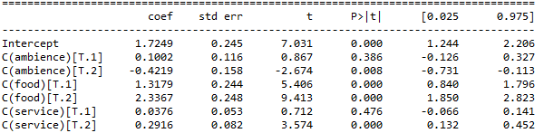

Logistic regression

Star = 1

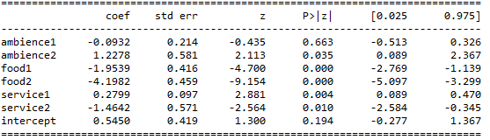

Star = 2

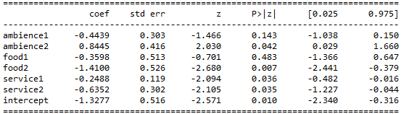

Star = 3

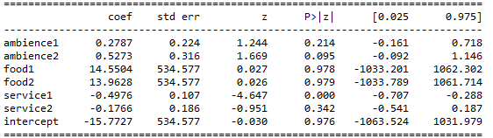

Star = 4

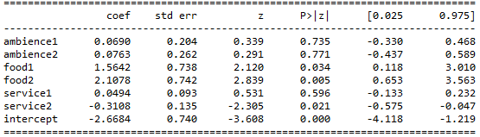

Star = 5

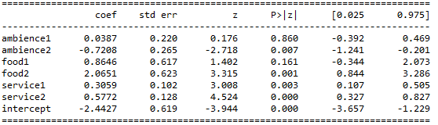

Mexican

Linear regression

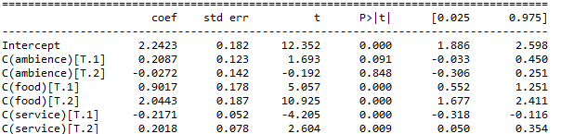

Logistic regression

Star = 1

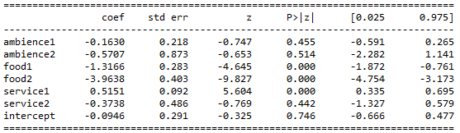

Star = 2

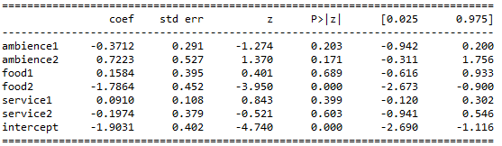

Star = 3

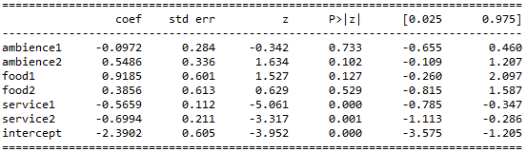

Star = 4

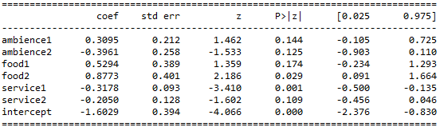

Star = 5

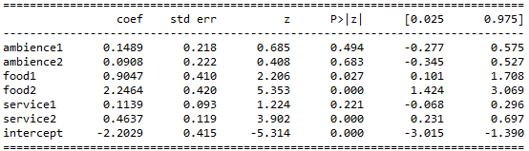

American

Linear regression

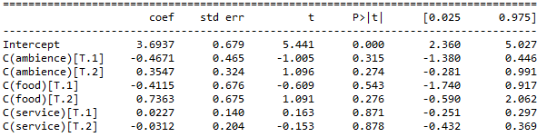

Logistic regression

Star = 1

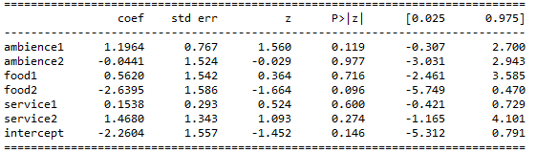

Star = 2

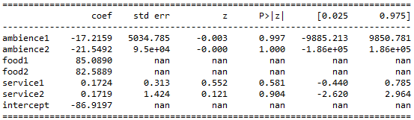

Star = 3

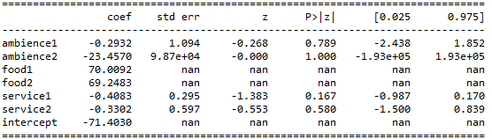

Star = 4

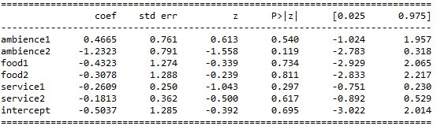

Star = 5

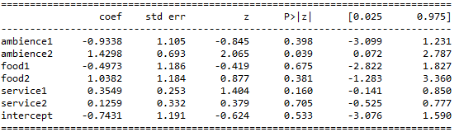

Japanese

Linear regression

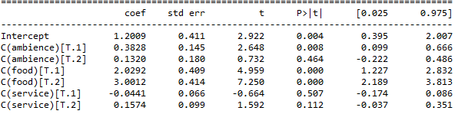

Logistic regression

Star = 1

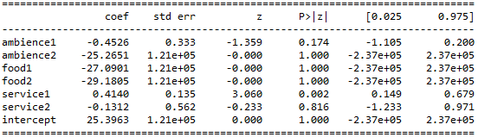

Star = 2

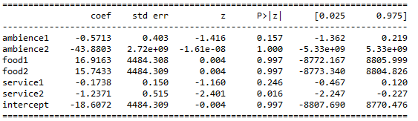

Star = 3

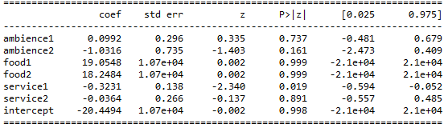

Star = 4

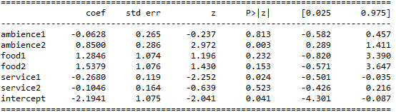

Star = 5

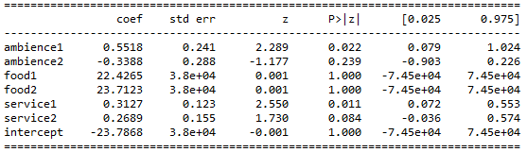

Canadian

Linear regression

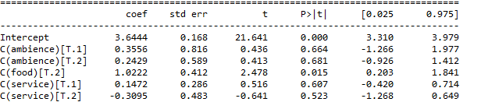

Logistic regression

Star = 1

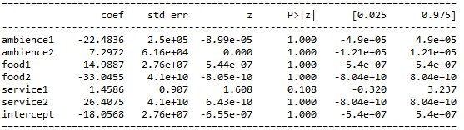

Star = 2

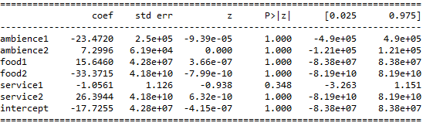

Star = 3

Star = 4

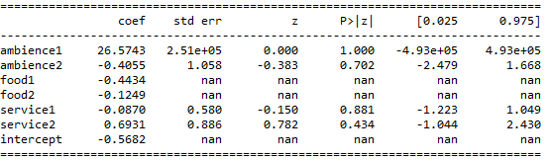

Star = 5

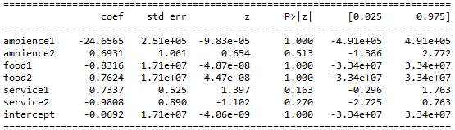

French

Linear regression

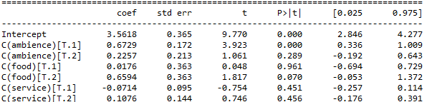

Logistic regression

Star = 1

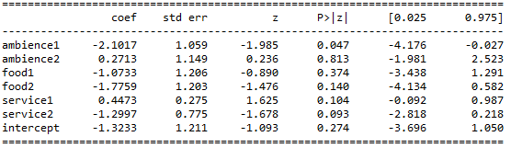

Star = 2

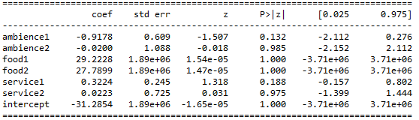

Star = 3

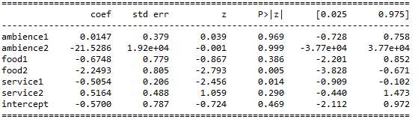

Star = 4

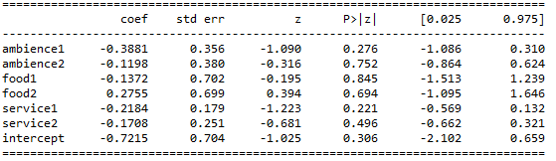

Star = 5

